**Code:**

import pandas as pd

import numpy as np

wbcd = pd.read_csv("C:\\Users\CSE-14\Desktop\wbcd.csv")

# converting B to Benign and M to Malignant

wbcd['diagnosis'] = np.where(wbcd['diagnosis'] == 'B', 'Benign ', wbcd['diagnosis'])

wbcd['diagnosis'] = np.where(wbcd['diagnosis'] == 'M', 'Malignant ', wbcd['diagnosis'])

wbcd = wbcd.iloc[:, 1:] # Excluding id column

desc = wbcd.describe()

# Normalization function

def norm_func(i):

x = (i-i.min()) / (i.max()-i.min())

return (x)

# Normalized data frame (considering the numerical part of data)

wbcd_n = norm_func(wbcd.iloc[:, 1:])

norm_data = wbcd_n.describe()

X = np.array(wbcd_n.iloc[:,:]) # Predictors

Y = np.array(wbcd['diagnosis']) # Target

from sklearn.model_selection import train_test_split

X_train, X_test, Y_train, Y_test = train_test_split(X, Y, test_size = 0.2)

# Imbalance check

wbcd.diagnosis.value_counts()

ytrain = pd.DataFrame(Y_train)

ytest = pd.DataFrame(Y_test)

ytrain.value_counts()

ytest.value_counts()

from sklearn.neighbors import KNeighborsClassifier

knn = KNeighborsClassifier(n_neighbors = 21)

knn.fit(X_train, Y_train)

pred = knn.predict(X_test)

pred

# Evaluate the model

from sklearn.metrics import accuracy_score

print(accuracy_score(Y_test, pred))

pd.crosstab(Y_test, pred, rownames = ['Actual'], colnames= ['Predictions'])

# error on train data

pred_train = knn.predict(X_train)

print(accuracy_score(Y_train, pred_train))

pd.crosstab(Y_train, pred_train, rownames=['Actual'], colnames = ['Predictions'])

# creating empty list variable

acc = []

# running KNN algorithm for 3 to 50 nearest neighbours(odd numbers) and

# storing the accuracy values

for i in range(1, 50, 2):

neigh = KNeighborsClassifier(n_neighbors = i)

neigh.fit(X_train, Y_train)

train_acc = np.mean(neigh.predict(X_train) == Y_train)

test_acc = np.mean(neigh.predict(X_test) == Y_test)

acc.append([train_acc, test_acc])

import matplotlib.pyplot as plt # library to do visualizations

# train accuracy plot

plt.plot(np.arange(1,50,2),[i[0] for i in acc],"ro-")

# test accuracy plot

plt.plot(np.arange(1,50,2),[i[1] for i in acc],"bo-")

**Outputs:**

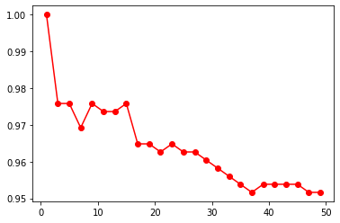

**Scatter plot for accuracy of Train dataset**

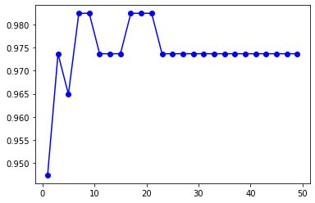

**Scatter plot for accuracy of Test dataset**